**Project -3**

**Integrate Grafana with Linux Server for high cpu utilization and create a graph in Grafana.**

**Table of content :-**

* Introduction
* What’s Grafana?
* Grafana’s core functionalities
* Grafana’s step-by-step installation

**Introduction**

In today’s IT infrastructure, **monitoring server performance** is critical to ensure the availability, stability, and efficiency of applications and services. One of the key performance metrics in any Linux server environment is **CPU utilization**. High CPU usage can lead to server slowdowns, service outages, and poor user experience. Therefore, continuous monitoring and visualization of CPU utilization is essential for **system administrators** and **DevOps engineers**. This project focuses on intregating Grafana with a linux server to monitor high CPU utilization and visualize the data using interactive dashboards and graphs.

**What’s Grafana?**

**Grafana** is an open-source analytics and interactive visualization web application. It allows you to **query**, **visualize**, **alert on**, and **explore** your metrics, logs, and traces from multiple data sources, all in one place.

It is widely used for **monitoring infrastructure**, **server performance**, **application monitoring**, **IoT device monitoring**, and even **business intelligence dashboards.**

**Key features of Grafana :-**

|  |  |
| --- | --- |
| Feature | Description |
| Data Visualization | Grafana converts raw data into interactive charts, graphs, and alerts. |
| Supports Multiple Data Sources | You can connect Grafana with databases like Prometheus, InfluxDB, MySQL, PostgreSQL, AWS CloudWatch, Elasticsearch, etc. |
| Custom Dashboards | Create fully customizable and dynamic dashboards to visualize data from different sources. |
| Alerting | Set conditions on your data and get alerts (Email, Slack, Webhooks, etc) when something goes wrong (like CPU > 90%). |
| Templating | Allows you to create dashboards with variables so that you can easily switch between servers, instances, or regions. |
| User Management | Manage user roles (Admin, Editor, Viewer) with access control and sharing features. |
|  |  |

**Core Functionalities :-**



**Step-by-step guide:-**

**Step 1:- create an ec2 server**

* **Login into your AWS account and go to EC2.**
* **Next , launch an Ec2 instance.**
* **Give name and choose ubuntu linux un AMI.**

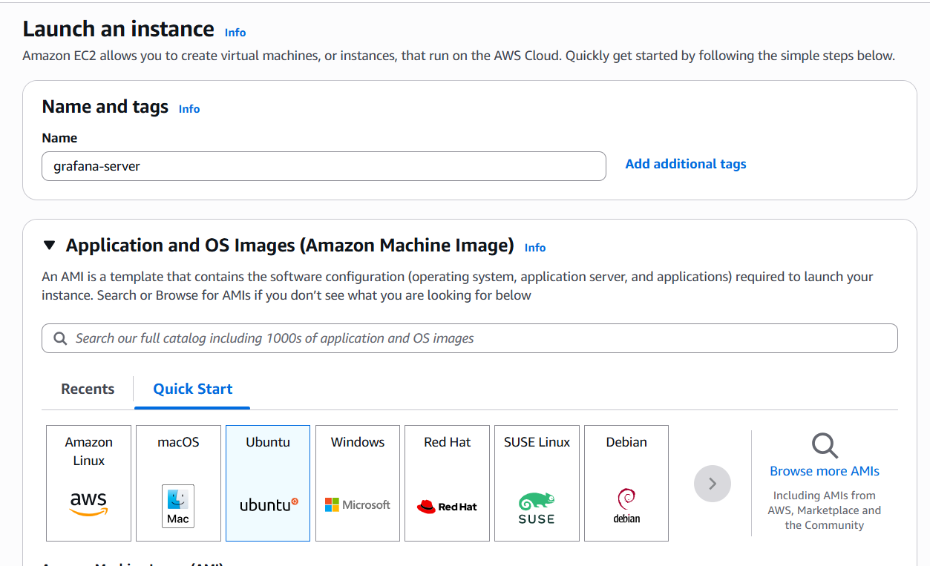

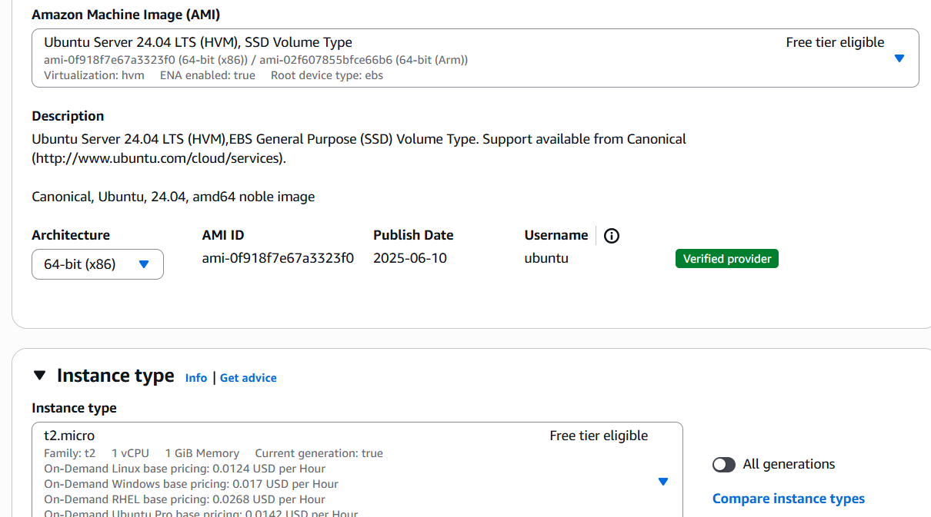

**N**

* **Now create a new keypair**

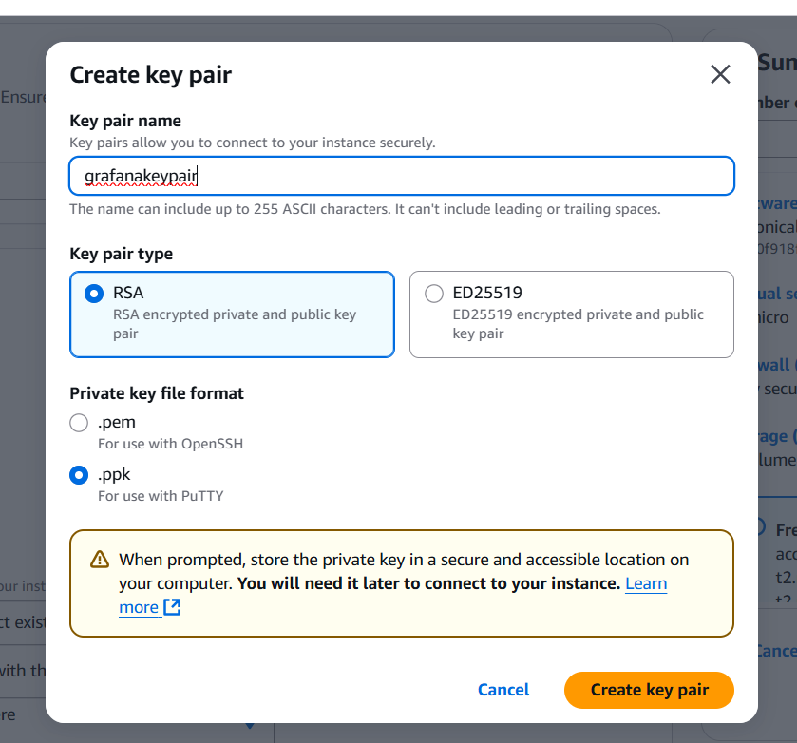

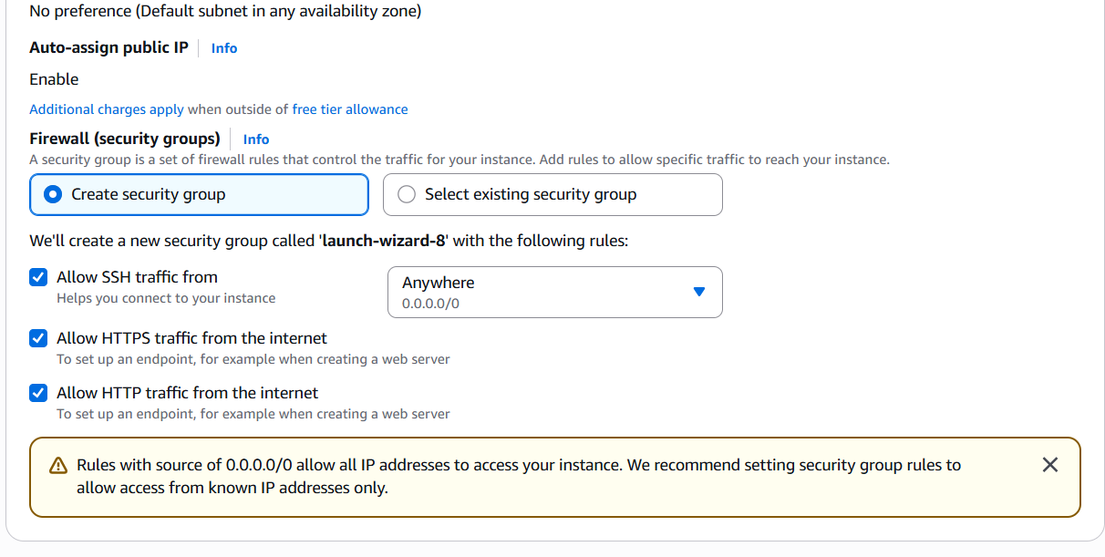

**After launching the instances copy the public ip address of your instance and connect it with putty and login as :ubuntu and then press enter.**

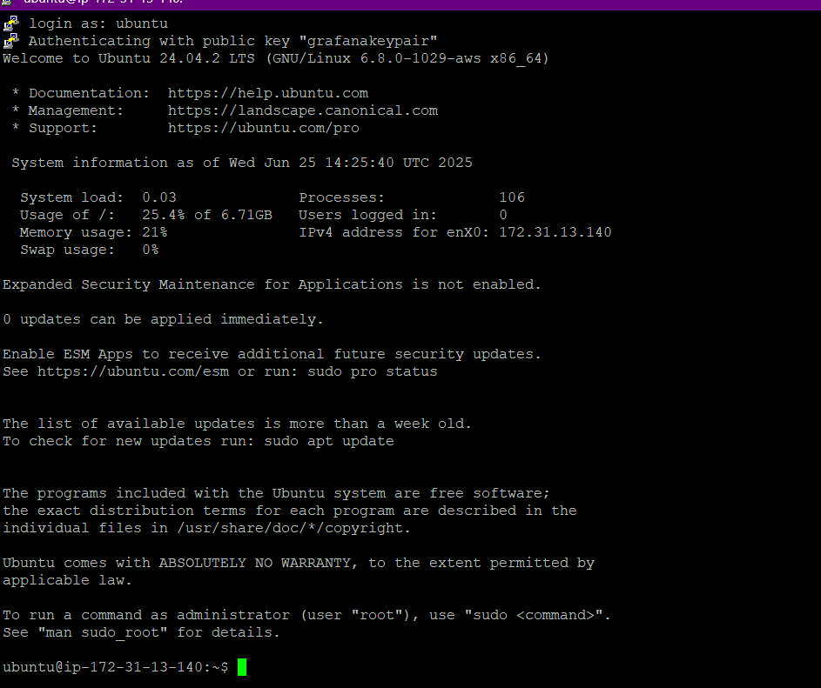

**After this step run all these commands :-**

**1. sudo apt update &&sudo apt upgrade -y**

**2. wget -q -O - https://packages.grafana.com/gpg.key | sudo apt-key add -**

**3. echo "deb https://packages.grafana.com/oss/deb stable main" | sudo tee /etc/apt/sources.list.d/grafana.list**

**4. sudo apt-get install -y apt-transport-https**

**sudo apt-get install -y software-properties-common wget**

**wget -q -O - https://packages.grafana.com/gpg.key | sudo apt-key add -**

**echo "deb https://packages.grafana.com/oss/deb stable main" | sudo tee /etc/apt/sources.list.d/grafana.list**

**sudo apt-get update**

**sudo apt-get install Grafana**

**5. sudosystemctl daemon-reexec**

**sudosystemctl start grafana-server**

**sudosystemctl enable grafana-server**

**6. ls /lib/systemd/system/grafana-server.service**

**7. sudo apt remove grafana**

**sudo apt update**

**sudo apt install grafana**

**8. sudo apt update &&sudo apt upgrade –**

**9. wget -q -O - https://packages.grafana.com/gpg.key | sudo apt-key add -**

**10. echo "deb https://packages.grafana.com/oss/deb stable main" | sudo tee /etc/apt/sources.list.d/grafana.list**

**11. sudo apt update**

**12. sudo apt install grafana -y**

**13. sudosystemctl start grafana-server**

**14. sudosystemctl enable grafana-server**

**15. sudosystemctl status grafana-server**

**After running all these commands go to your instance which you’ve created earlier and go to security and then go to security groups :-**



**Click on the security groups and then select the inbound rules :-**

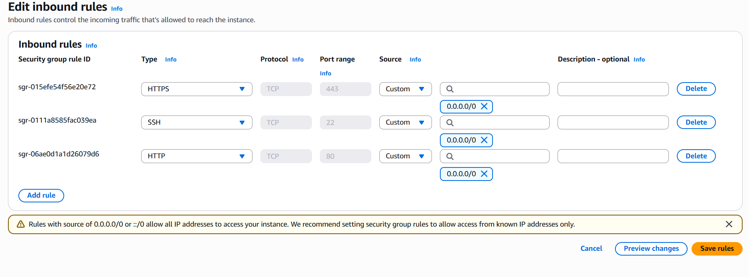

* **Now create on add rules and give port range 3000 and source 0.0.0.0/0 and then click on save rules.**
* **After saving rules copy your instance’s public ip address and place that ip with port range 3000 in your browser .**



* 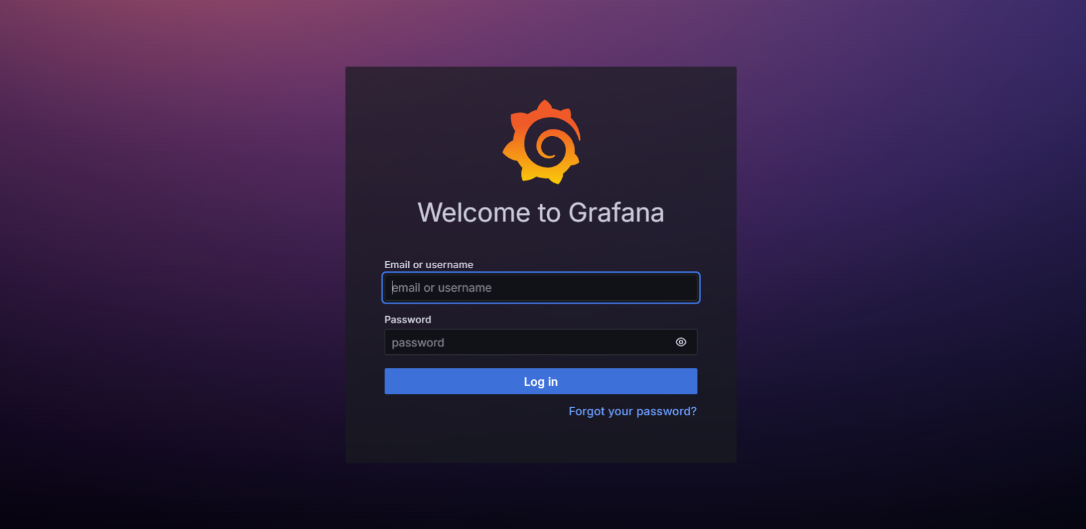After putting ip with port range you’ll get this **Grafana** **interface.**
* **For making account in Grafana you’ve to write Admin in “email or username” and “password” both.**

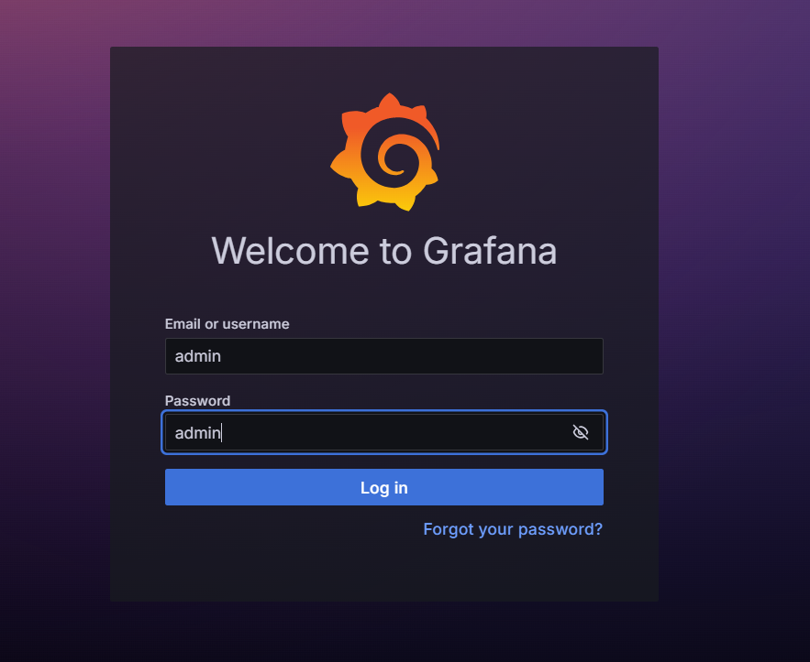

* **After this it’ll suggest you to create a new password and after that your main Grafana page will be open.**

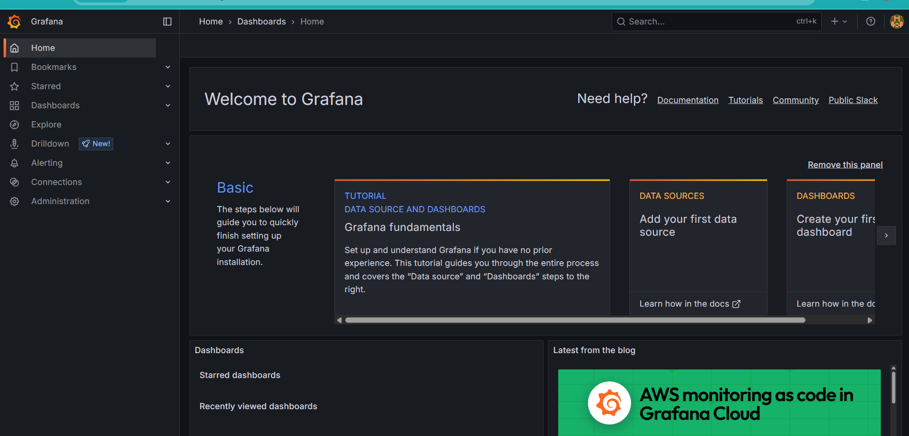

* **Now go to connections on the left and data source.**
* **Click on the add data source.**
* **Search cloud watch and open it**

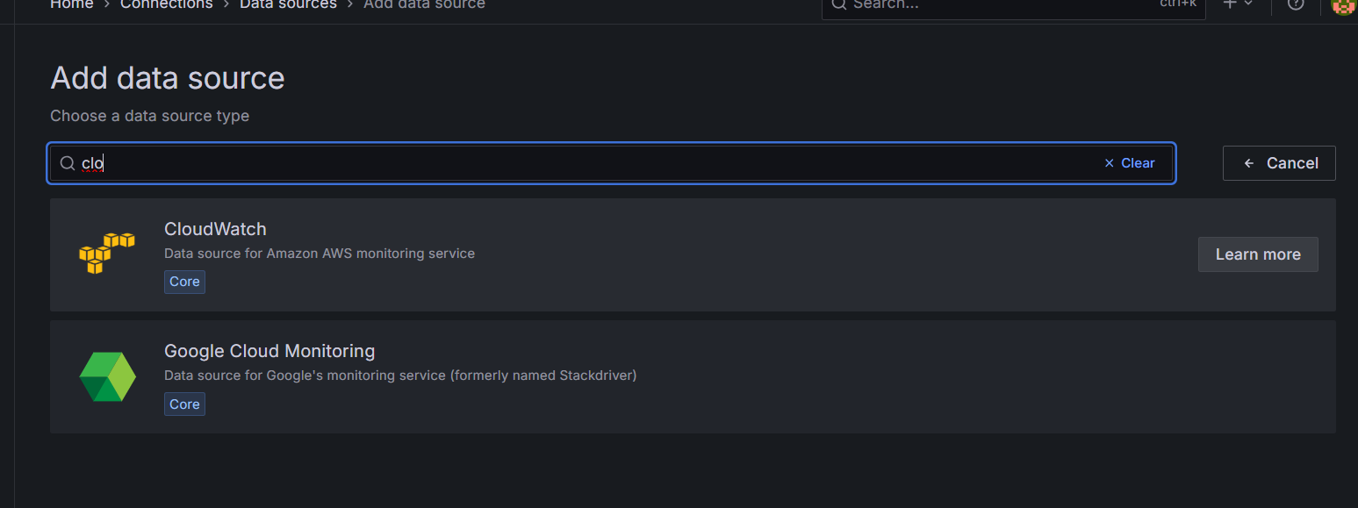

**In connection details:-**

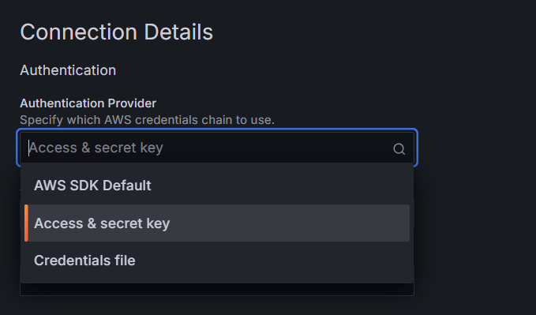

* **Now go to the IAM if you are aiam user and go to your user id if you are a root user then make your own user.**

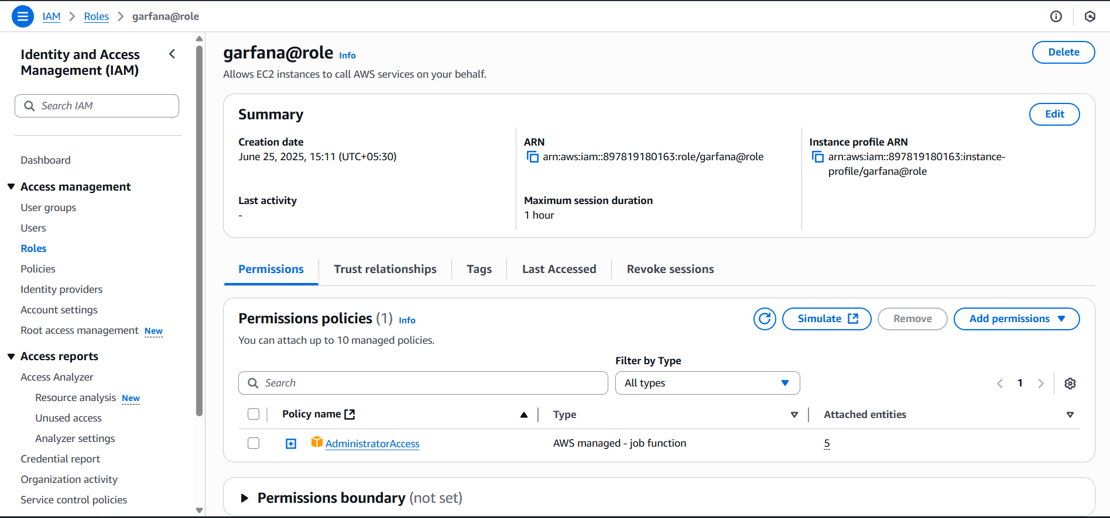

**Now go to security credentials**

* 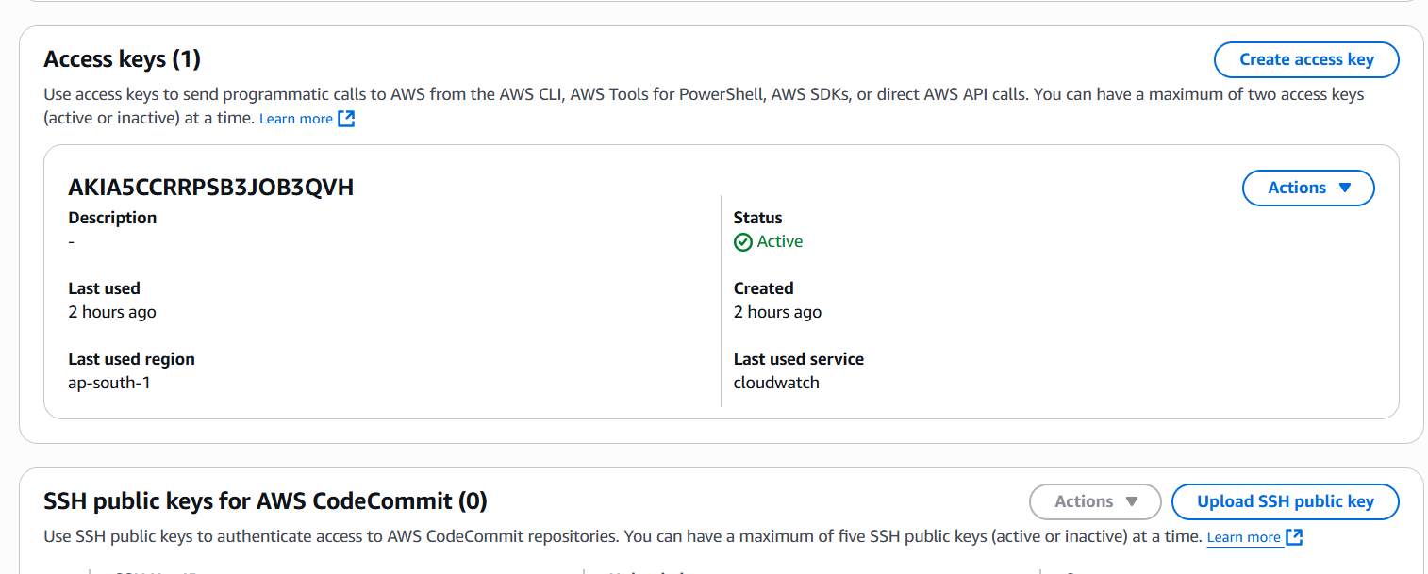**Create on access key**

**Now select Command Line interface(CLI):-**

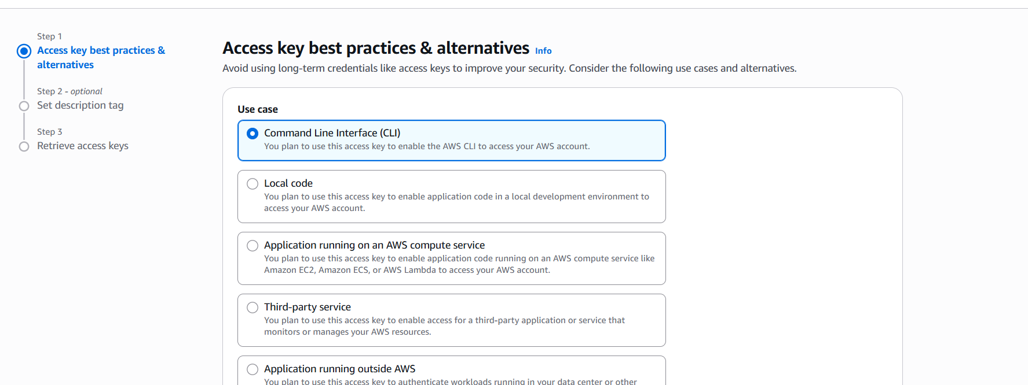

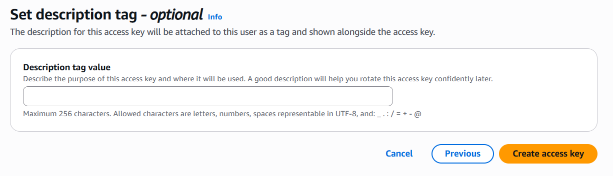

**Click on create access key :-**

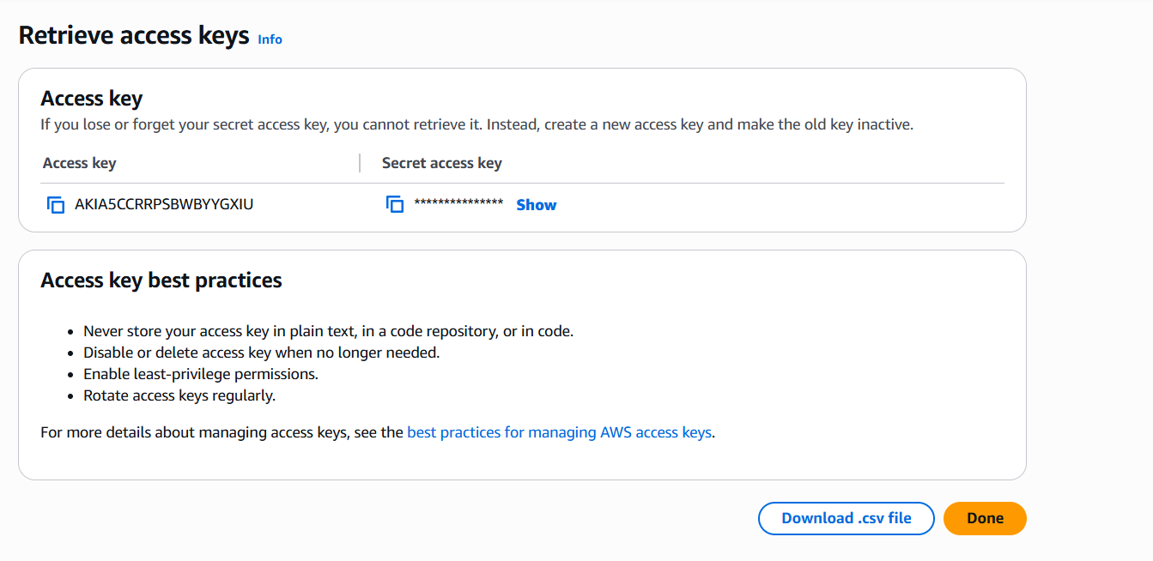

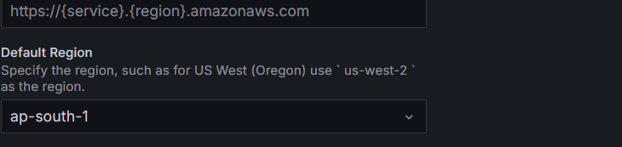**Now your access key and secret access key is created copy them and paste it and choose region what you choose in the instance.**

**Now click on save and test:-**



* 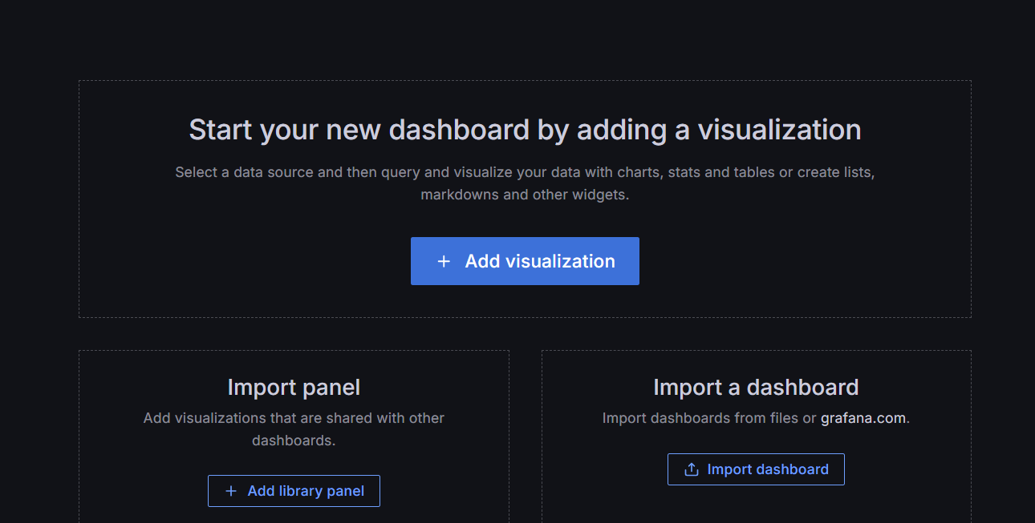**Now next step is we’ve to go to home and click on dashboard.**
* **Click on import dashboard**
* **Now click on grafana.com/dashboards**
* **Search AWS EC2 and open it.**

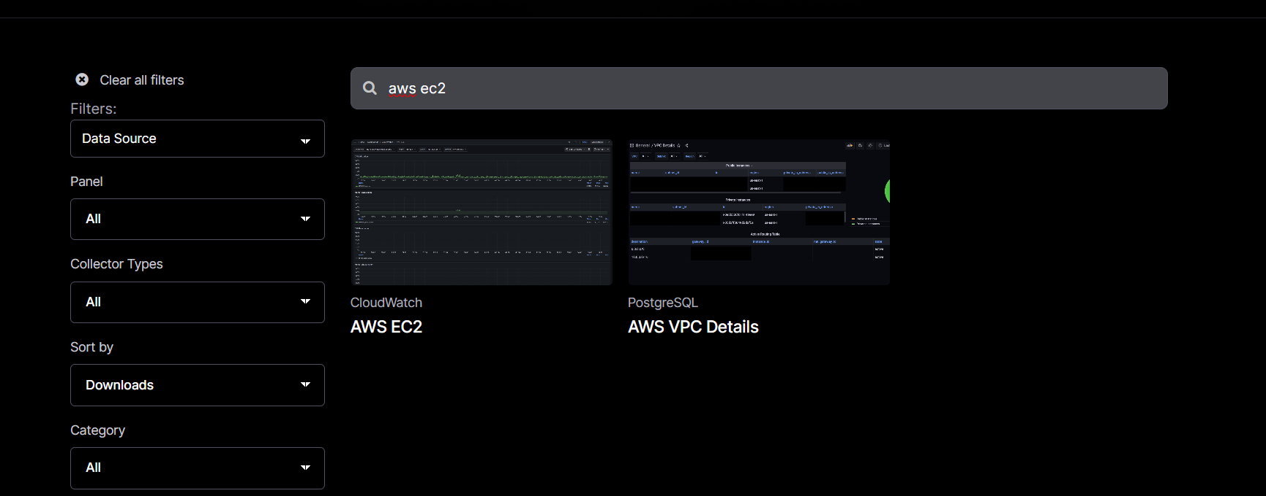

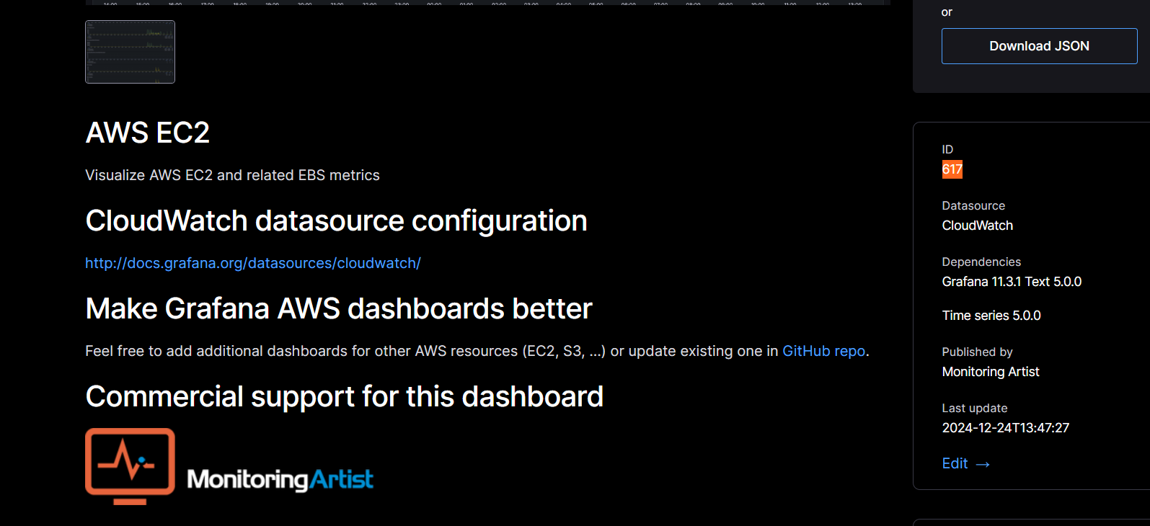

* **Now copy the “id number” and place it in dashboard.**

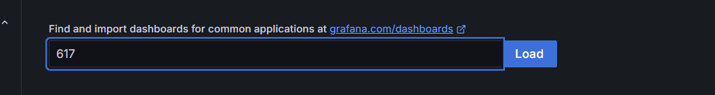

* 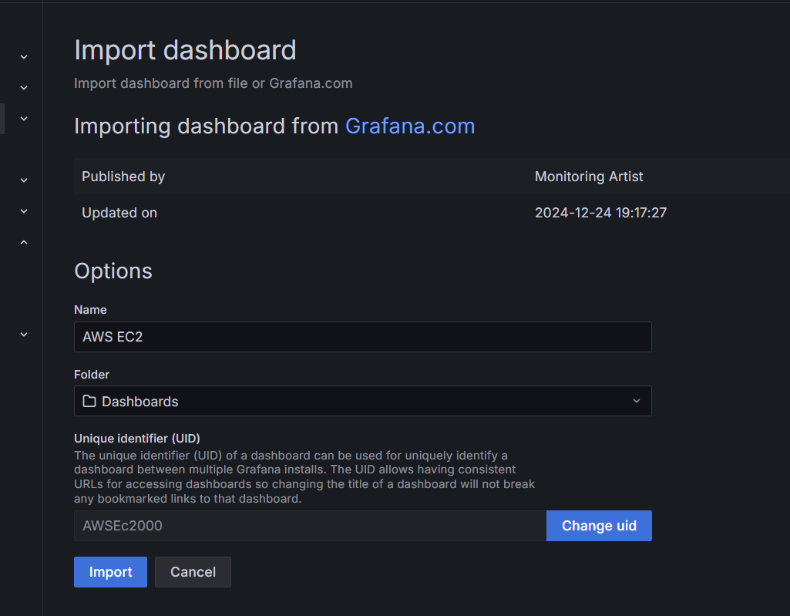**And after pasting id number tap on load this interface will appear.**
* **Now click on import and put cloudwatch in your datasource :-**
* **Region: ap-south1**
* **Tag-name: your instance name**

**Choose refresh time 5 seconds and time last 15 minutes. **

**Your grafana’s interface will appear soon:-**

